Gold Standard for the Global Goals
Template – Additionality Requirements for Afforestation/Reforestation Projects

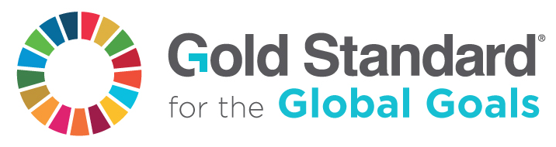

Version 1 – July 2017

SECTION A. PROJECT DESCRIPTION

A. 1. Title of the project
Title:
Date:
Version no.:
Gold Standard ID:

A. 2. Type of project

Afforestation/Reforestation (A/R)
Improved Forest Management (IFM)

Smallholder
Microscale

SECTION B. ADDITIONALITY

Option of Additionality
Option 1 – A/R CDM Tool Option 2 – Positive List

For option 1, the format of the A/R CDM Additionality Tool shall be followed and attached as supporting document. The requirements for retroactive submission and no deforestation (see boxes 3 and 4 below) shall also be fulfilled.

For option 2, the requirements shall be filled in using the format provided by this template.

Option 1 – A/R CDM Tool

Supporting document ID: | …

Option 2 – Positive List – Part I

- The project shall meet all of the requirements (a), (b) and (c) in the list below and at least one of the requirements from (d) to (g) in order to be considered as additional under Option 2.

- The project is located in a Less Developed Country (LDCs) or in a region with a recent UNDP Human Development Indicator below 0.8.
- The project shall have no intention of creating a forest for the commercial use of the timber or non-timber forest products.
- The project activities shall not be mandatory by any law or regulation, OR if it is mandatory, it shall demonstrate that these laws or regulations are systematically not enforced.
(a) | …
(b) | …
(c) | …

Option 2 – Positive List – Part II

- The project shall meet all of the requirements (a), (b) and (c) in the list below and at least one of the requirements from (d) to (g) in order to be considered as additional under Option 2.

- The project area is located in a region with a mean annual precipitation of less than 600 mm.
- The soil pH of the planting area is less than 4.0.
- The planting area is planted with minimum 5 different native tree species in mixed stands, covering at minimum 50% of the planting area.
- The project area is located:
  - In a country or region with a recent UNDP Human Development Indicator¹ below 0.5, OR
  - In a Small Island Developing State (SIDS)
(d) | …
(e) | …
(f) | …
(g) | …

Retroactive submission

- If the submission to the Pre-Feasibility Assessment was after the planting start, the project proponent shall demonstrate that
- the revenues from CO2-certificates were seriously considered in the decision to implement the project, AND
- there was continuous interest in CO2-certificates for the project in parallel with its implementation.
(a) | …
(b) | …

No deforestation

- The planting area shall not have been forest for at least 10 years prior to the planting start, OR
In case the planting area was deforested in the 10 years prior to the planting start, evidence shall be provided which demonstrates that the deforestation was caused by force majeure.
…

A/R CDM Additionality Tool http://cdm.unfccc.int/methodologies/ARmethodologies/tools/ar-am-tool-02-v1.pdf
UNDP Human Development Indicator http://hdr.undp.org/en/data/profiles/
Small Island Developing States (SIDS) https://sustainabledevelopment.un.org/topics/sids
Forest A forest is defined by the Designated National Authority (DNA) of the project’s host-country: http://cdm.unfccc.int/DNA

